|  |  |  |  |  |  |  |  |
| --- | --- | --- | --- | --- | --- | --- | --- |
| Test Case ID | Use case ref | **Description of Test** | **Test Initialisation** | **Test Inputs** | **Test Procedure** | **Expected Results** | **Passed?** |
| tN001 | N/A | **Start the Air Hockey Server.** |  |  | **Run AirHockeyServer.exe** | **Server console should open and the name of the Server Host should be displayed** |  |
| tN002 | N/A | **Stop the Air Hockey Server** |  | **Escape key .** | **User presses the escape key** | **The air hockey server should exit** |  |
| tN003 | N/A | **Change the server address in the options screen** | **Game must be in options menu** | **Alphanumeric keys.** | **Change the server address using your keyboard from “localhost” to “GTLAPTOP”** | **The server address should change.** |  |
| tN004 | N/A | **Change the server port in the options screen** | **Game must be in options menu** | **Alphanumeric keys.** | **Change the server address using your keyboard from 2000 to 1000** | **The server port should change** |  |
| tN005 | N/A | **Start a multiplayer game** | **Game must be in main menu.** | **Arrow keys and space bar.** | **The user selects the Start Multiplayer Game from the main menu.** | **A new game should start with the user controlling the left hand blue paddle.** |  |
| tN006 | N/A | **Find a Multiplayer game** | **Game must be in main menu.** | **Arrow keys and space bar** | **The user selects the Start Multiplayer Game from the main menu.** | **A new game should start with the user controlling the right hand red paddle.** |  |
| tN001 | N/A | **Start the Air Hockey Server.** |  |  | **Run AirHockeyServer.exe** | **Server console should open and the name of the Server Host should be displayed** |  |

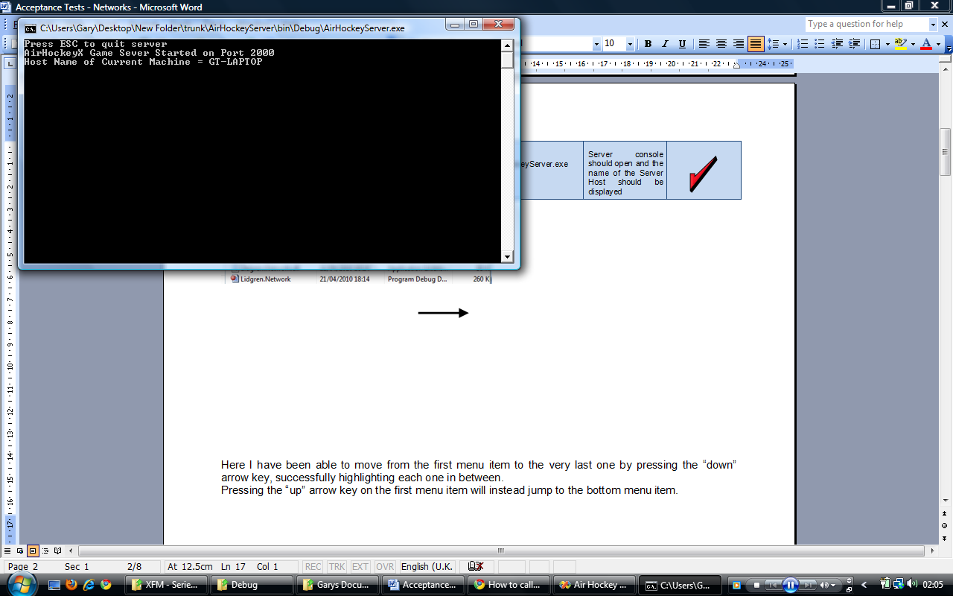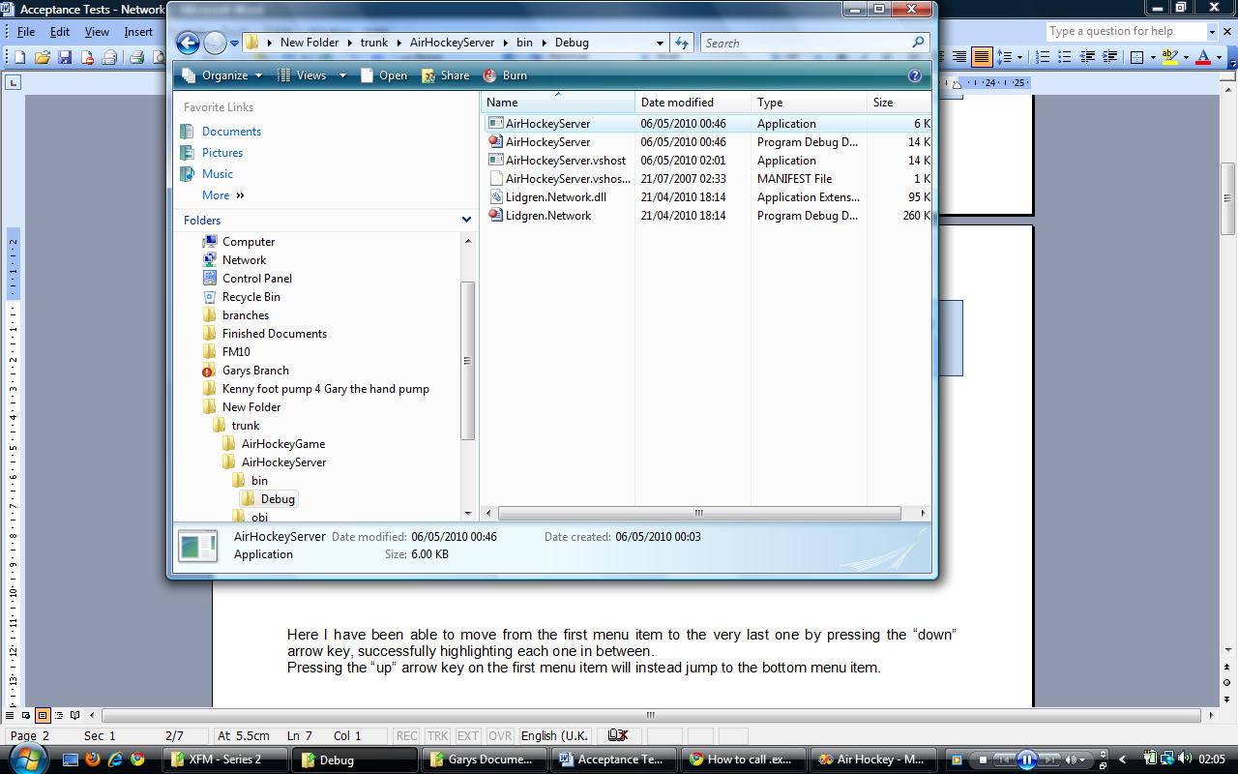

Here I ran the AirHockeyServer.exe and the server successfully started.

|  |  |  |  |  |  |  |  |
| --- | --- | --- | --- | --- | --- | --- | --- |
| tN002 | N/A | **Stop the Air Hockey Server** |  | **Escape key .** | **User presses the escape key** | **The air hockey server should exit** |  |

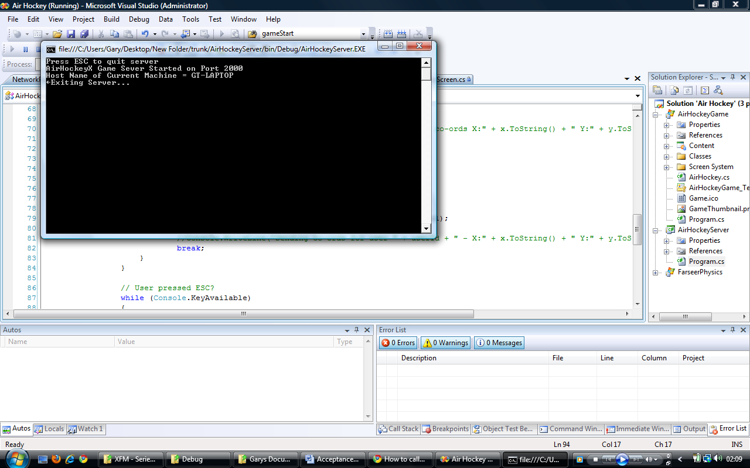

Here I have pressed the escape key on the server console and the server successfully exits.

|  |  |  |  |  |  |  |  |
| --- | --- | --- | --- | --- | --- | --- | --- |
| tN003 | N/A | **Change the server address in the options screen** | **Game must be in options menu** | **Alphanumeric keys.** | **Change the server address using your keyboard from “localhost” to “GTLAPTOP”** | **The server address should change.** |  |

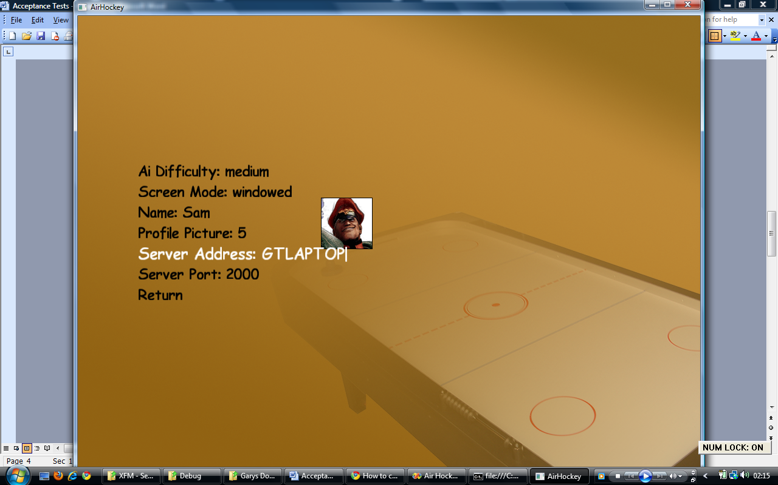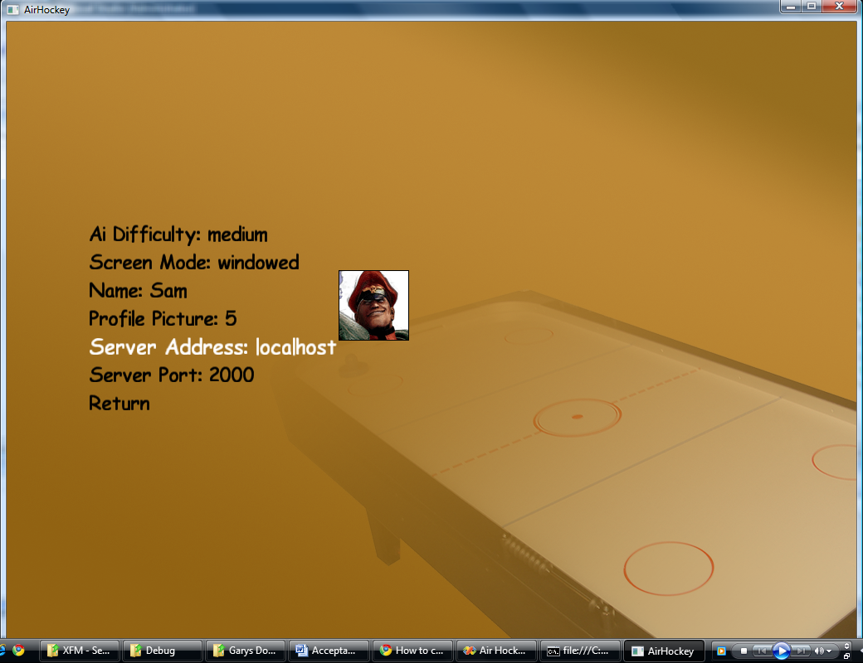

In the options menu, I have selected the Server Address menu option and changed it from localhost to GTLAPTOP

|  |  |  |  |  |  |  |  |
| --- | --- | --- | --- | --- | --- | --- | --- |
| tN004 | N/A | **Change the server port in the options screen** | **Game must be in options menu** | **Alphanumeric keys.** | **Change the server address using your keyboard from 2000 to 1000** | **The server port should change** |  |

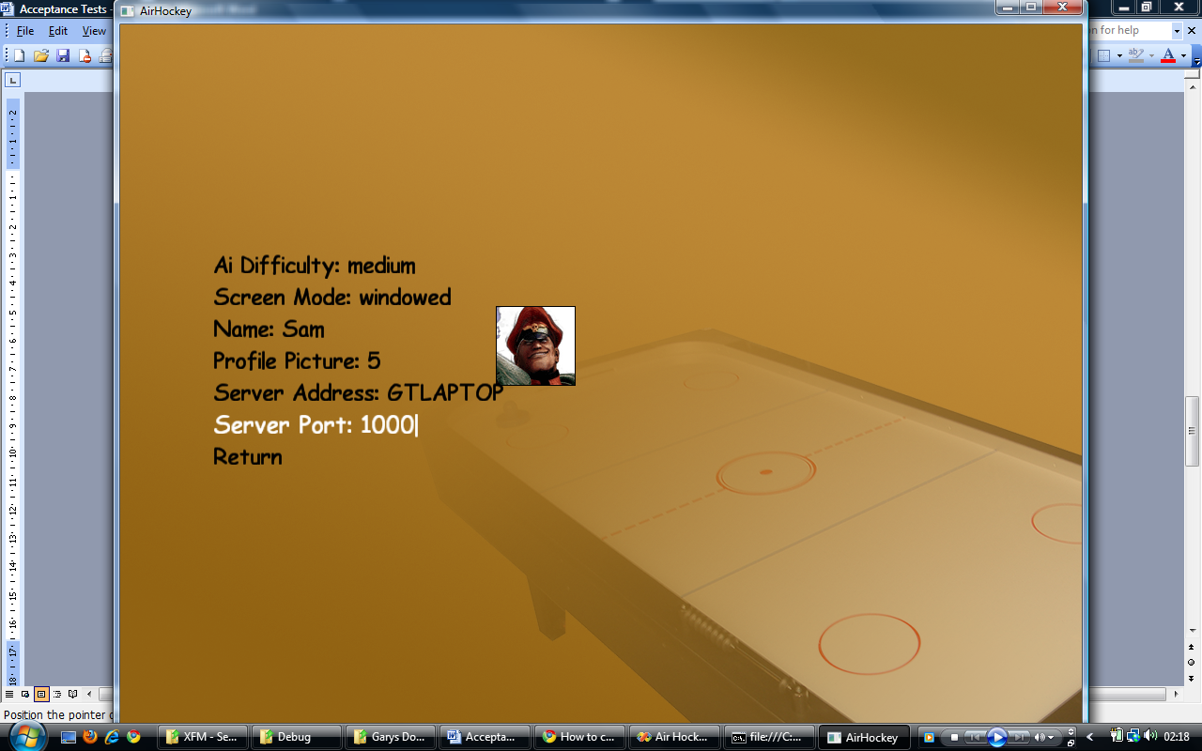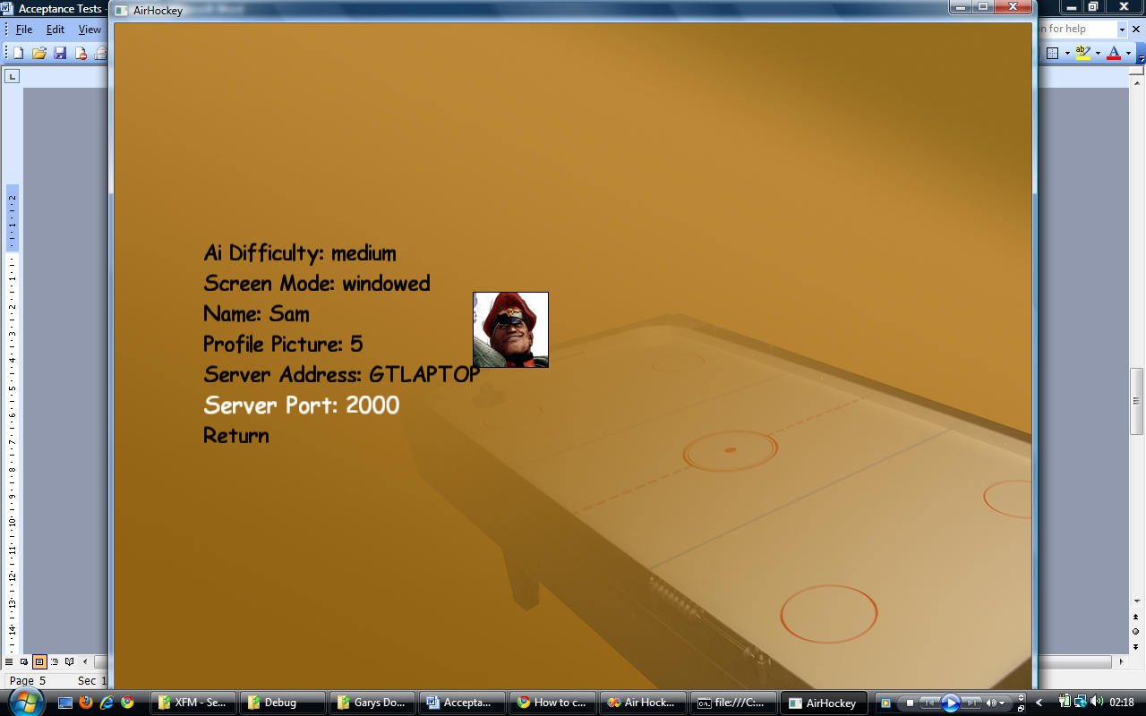

|  |  |  |  |  |  |  |  |
| --- | --- | --- | --- | --- | --- | --- | --- |
| tN005 | N/A | **Start a multiplayer game** | **Game must be in main menu.** | **Arrow keys and space bar.** | **The user selects the Start Multiplayer Game from the main menu.** | **A new game should start with the user controlling the left hand blue paddle.** |  |

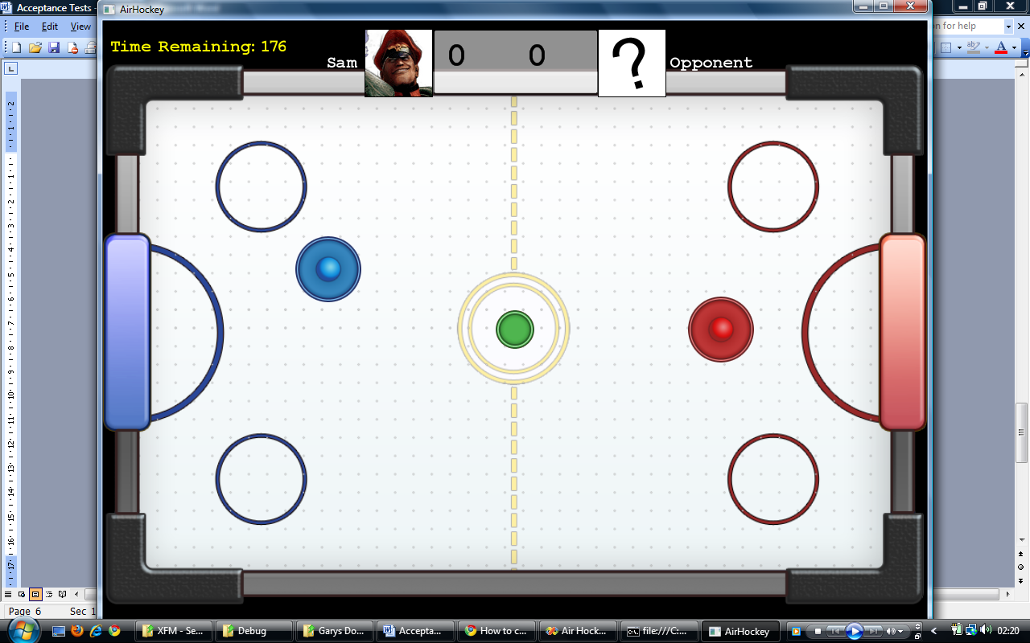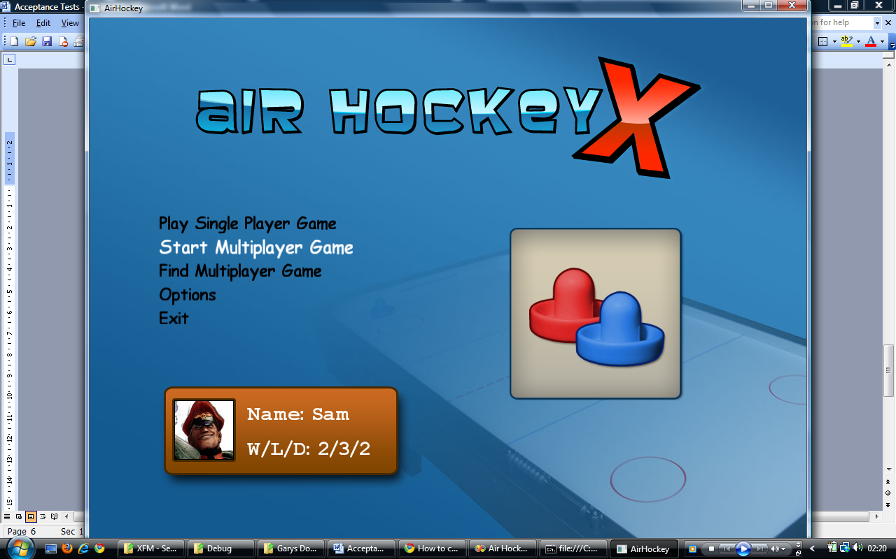

Here I have selected to Start Multiplayer Game you can see that player has control of the left hand puck and the players profile picture and name are printed on the left hand side of the score board.

|  |  |  |  |  |  |  |  |
| --- | --- | --- | --- | --- | --- | --- | --- |
| tN006 | N/A | **Find a Multiplayer game** | **Game must be in main menu.** | **Arrow keys and space bar** | **The user selects the Start Multiplayer Game from the main menu.** | **A new game should start with the user controlling the right hand red paddle.** |  |

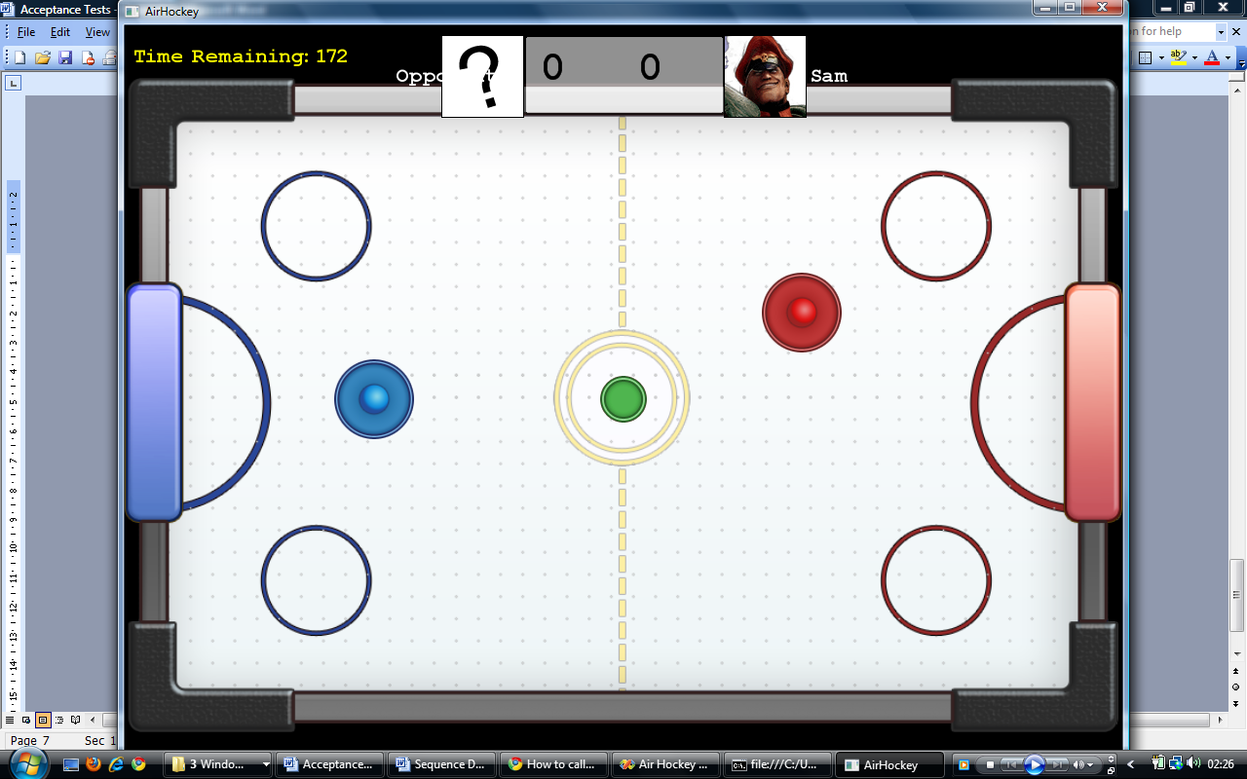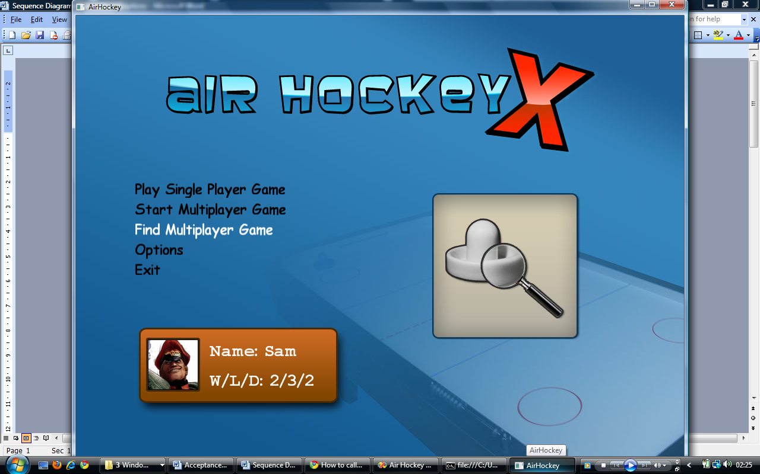

Here I have selected to Find Multiplayer Game you can see that player has control of the right hand puck and the players profile picture and name are printed on the right hand side of the score board.